**Data Section:**

Data used in this project is related to Toronto city in Canada. The locations from the Toronto can be found in the following link

<https://en.wikipedia.org/wiki/List_of_postal_codes_of_Canada:_M>

The following is the list of sample postcodes and neighbourhoods obtained after scraping the data in the above link.

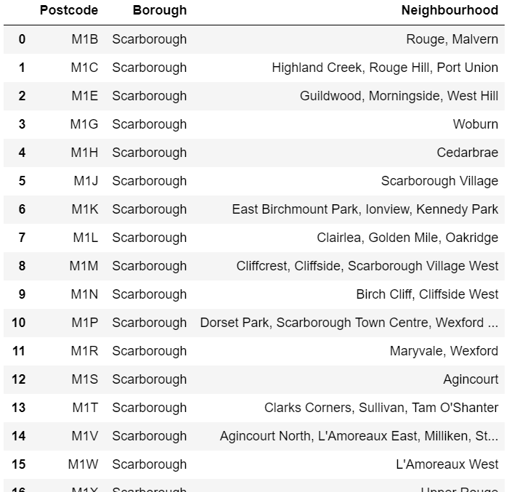

Total postcodes used in this project are 103.

The following is the list of table contains the longitude and latitude obtained using geolocator for the above postcodes.

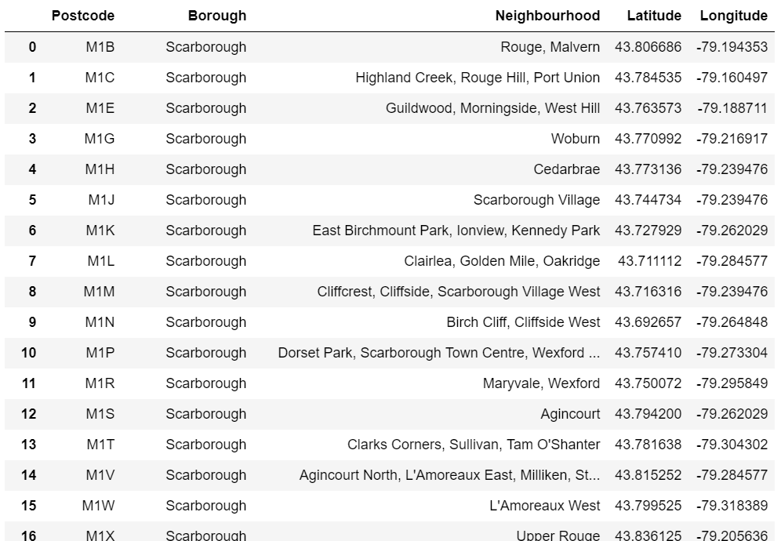

The following is map obtained using folium module by passing above data.

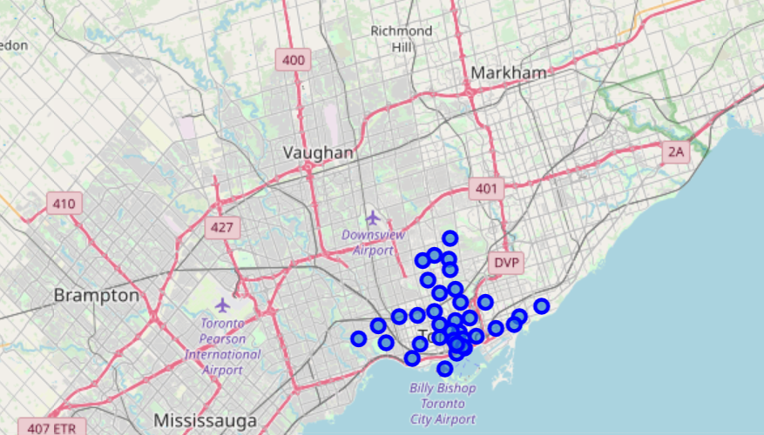

The following is the venue categories obtained by passing above data to Foursquare API.

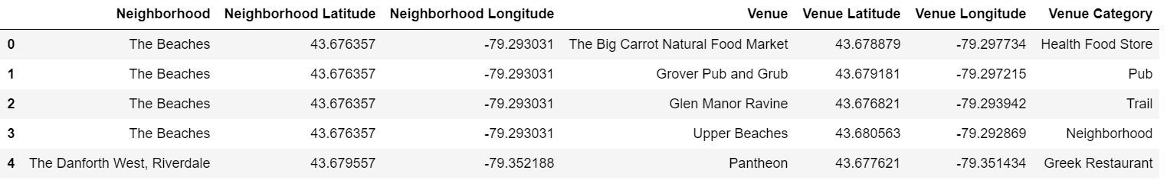

Data can be analysed by applying one hot code technique to the above data and dividing them into clusters. Decision can be suggested from the results and to be discussed in the results section.